|  |
| --- |
| **National University of Computer and Emerging Sciences** |
| Lab Manual  “Introduction to Power BI” |
|  |
| Data Warehousing and Data Mining |
|  |
|  |
|  |

|  |  |
| --- | --- |
| Course Instructor | Ishaq Raza |
| Lab Instructor(s) | Farhan Azhar  Nouman Ali |
| Semester | Fall 2019 |

|  |
| --- |
|  |

Department of Computer Science

FAST-NU, Lahore, Pakistan

**Overview of PowerBI**

**Overview**

[Power BI](https://powerbi.microsoft.com/en-us/) gives the ability to analyze and explore data on-premise as well as in the cloud. Power BI provides the ability to collaborate and share customized dashboards and interactive reports across colleagues and organizations, easily and securely.

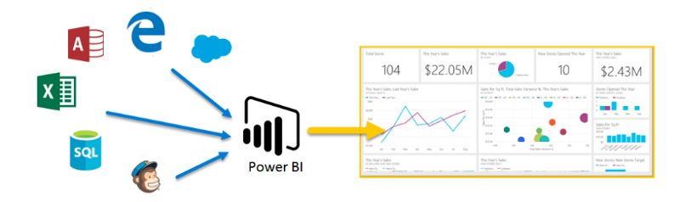

[Source](https://docs.microsoft.com/en-us/learn/modules/get-started-with-power-bi/1-introduction)

**Power BI’s Components**

Power BI consists of various components which are available in the market separately and can be used exclusively.

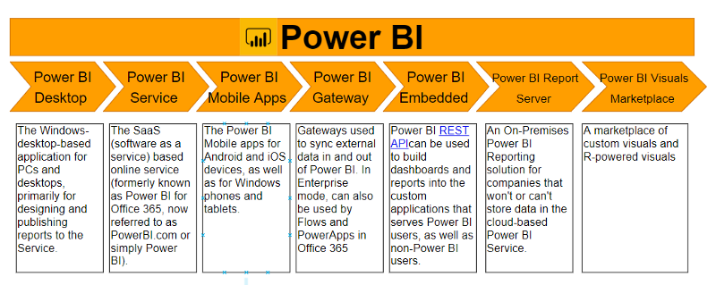

[Content Source](https://en.wikipedia.org/wiki/Power_BI)

Choosing which component to work with depends mainly on the project or a team. We, however, will be working with **Power BI desktop** since this is a component primarily used for Business reports generation and desktop creation. Also, all the other works typically begin with Power BI desktop, where the report creation takes place.

**2. Advantages of using Power BI**

Power BI provides certain benefits which make it superior to the existing analytical tools:

* Provides a cloud-based as well as a desktop interface.
* Provides capabilities like data warehousing, data discovery and interactive dashboards.
* Ability to load custom visualizations, and
* Easily scalable across the entire organization.

**3. Power BI Desktop**

Power BI is a free application that can be downloaded and installed on the system. It can be connected to multiple data sources. Usually, an analysis work begins in **Power BI Desktop** where report creation takes place. The report is then published to **Power BI service** from where it can be shared to the **Power BI Mobile apps** so that people can view the reports even on mobiles.

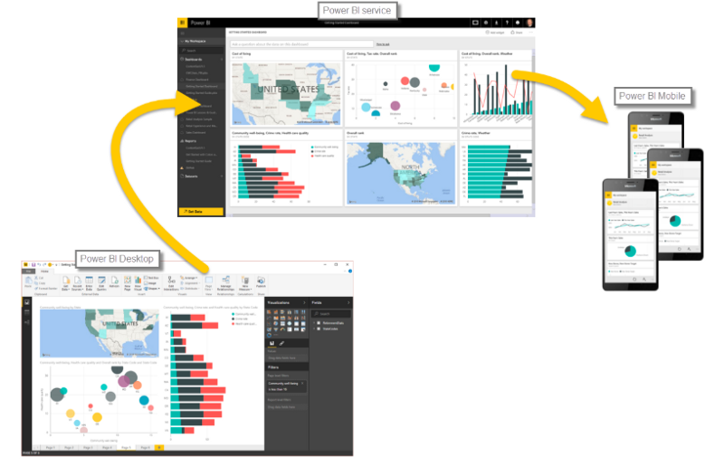

Source: <https://docs.microsoft.com/en-us/learn/modules/get-started-with-power-bi/2-using-power-bi>

**Installation**

Power BI only runs on Windows Machines. Mac users could spin up a Windows VM in Azure and load Power BI onto that or use [Turbo.net](https://turbo.net/run/powerbi/powerbi), which can stream Power BI to the Mac directly from the cloud.

Power BI can be used in two ways:

* As an app from the Microsoft store and just sign in to get started. This is the online version of the tool.
* [Download](https://www.microsoft.com/en-us/download/details.aspx?id=45331) the software locally and then install it. Make sure you read all the installation instructions.

Depending upon the choice of product, download the software on to the computer. After accepting the license agreement, verify the installation by clicking the Power BI Icon/App. If the following screen appears, you are good to go.

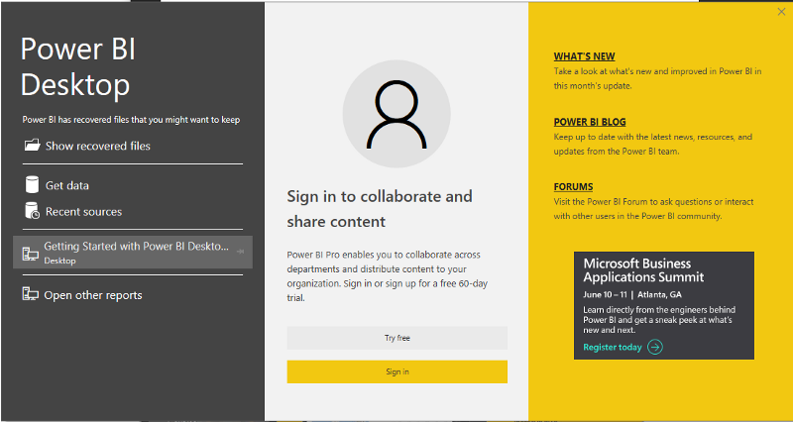

**4.Getting Started**

Let us now get an idea about working with Power BI Desktop. In this section, we shall explore it a bit to get accustomed to its interface.

**Power BI Workspace**

The image below highlights the major components of the workspace of Power BI.

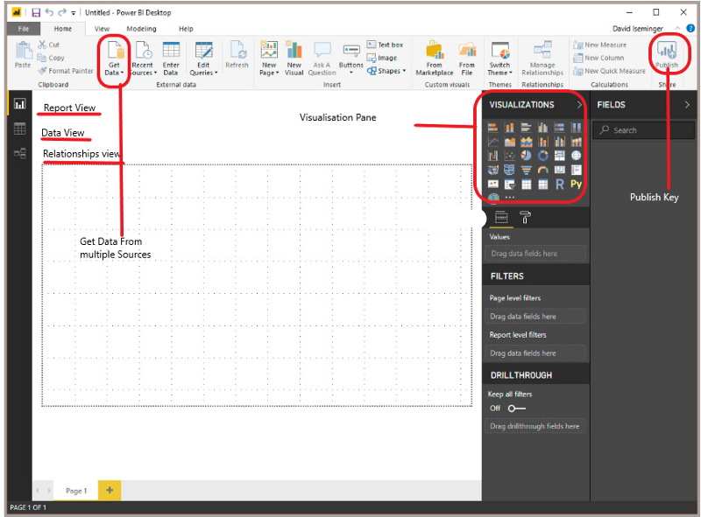

**Basic Views**

* **Report View**: This is the main view where the Dashboard is created.
* **Data View**: The data view gives a preview of the entire data.

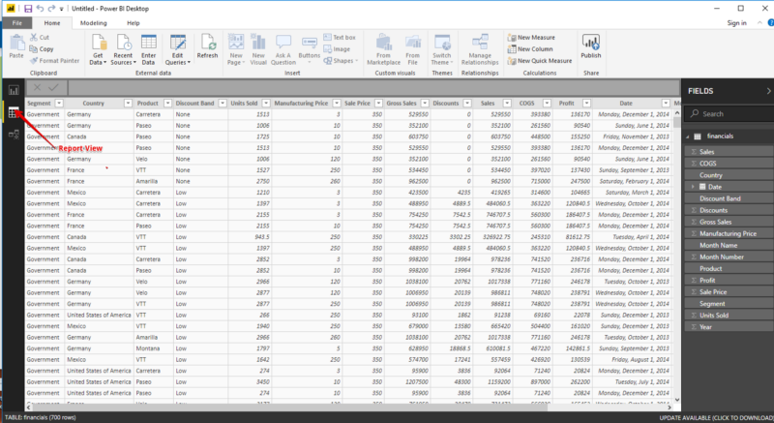

* **Relationship View**: The relationship view displays the relationship between various objects.

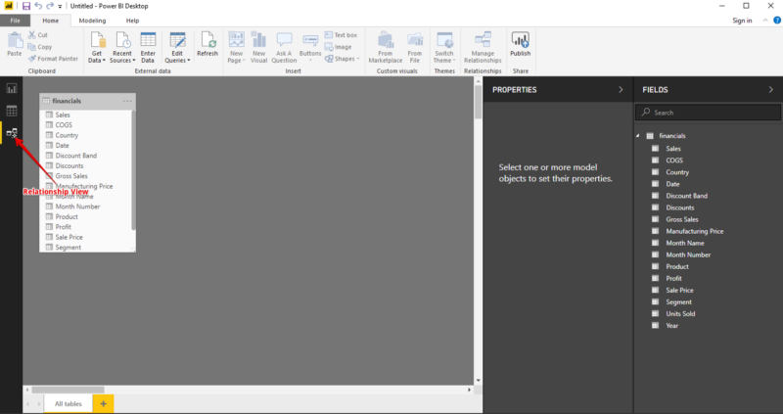

**Connecting to a Data Source**

Power BI can be connected to several data sources. The Get Data icon displays all the possible available options from where data can be imported into Power BI.



Let’s look at a few of the most commonly used data sources:

* **Excel data**

Let’s connect to an Excel data source. The workbooks consist of some fake financial data. Download the file from [here](https://github.com/parulnith/Data-Visualisation-libraries/blob/master/Data%20Visualisation%20with%20Power%20BI/Financial%20Sample.xlsx). Power BI Desktop loads the workbook and reads its contents, and shows you the data in the file using the Navigator window.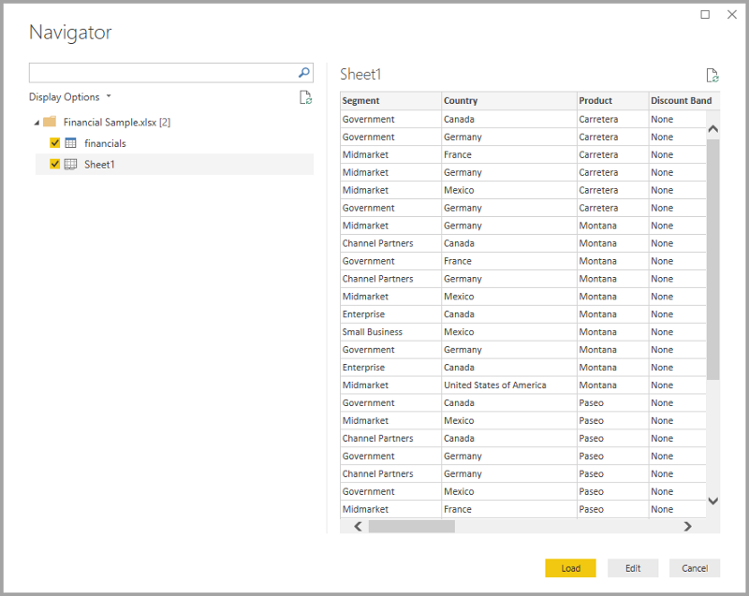

Once loaded, the data can be viewed in the **Fields** pane.

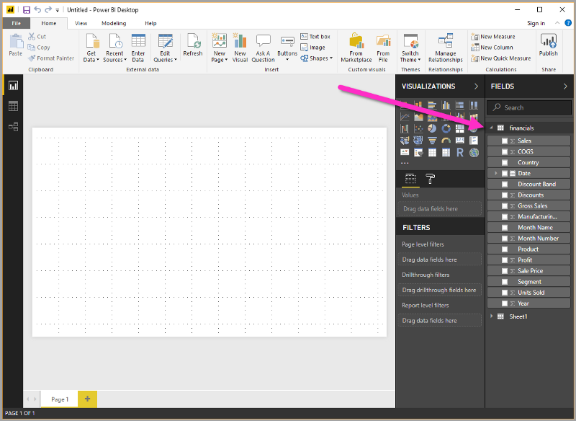

* **Web**

You can also use the data from the web. Here is a dataset which presents the best and the worst states for retirement in the U.S.

link: [*http://www.bankrate.com/finance/retirement/best-places-retire-how-state-ranks.aspx*](http://www.bankrate.com/finance/retirement/best-places-retire-how-state-ranks.aspx)

Simply select Web as an option in Get Data and enter the name of the url.

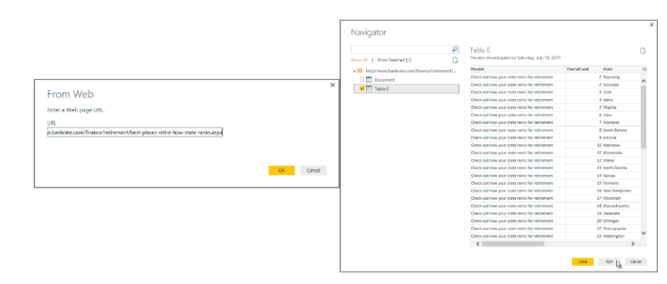

Try experimenting with other data sources too.

**5. Transforming Data**

After the data has been loaded, it becomes visible under the Fields Tab. From here, we can modify our datasets with the help of **Query Editor**. Query editor can be used for modifying datasets irrespective of their data source. We can do manipulations like renaming a dataset, removing a single or multiple columns, etc. in the query editor. The Query Editor can be accessed by clicking the Edit Queries button on the Home Ribbon.

**Creating a Custom Column**

Using the same [Financial data](https://github.com/parulnith/Data-Visualisation-libraries/blob/master/Data%20Visualisation%20with%20Power%20BI/Financial%20Sample.xlsx), that we used above, let’s shape data to meet our needs. Let’s create a custom column called New Manufacturing Price, which is equal to:

([manufacturing Price])*3



**Changing Column Data Types**

The data types of the columns can also be changed easily. The Units Sold column has a floating point data type which can be adjusted to a whole number.



**Removing Columns**

Removing columns is also easy. Simply select the column to be selected and choose the Remove Columns option, as shown in the following figure. Let’s get rid of the Discount column as it is adding no value to our dataset.

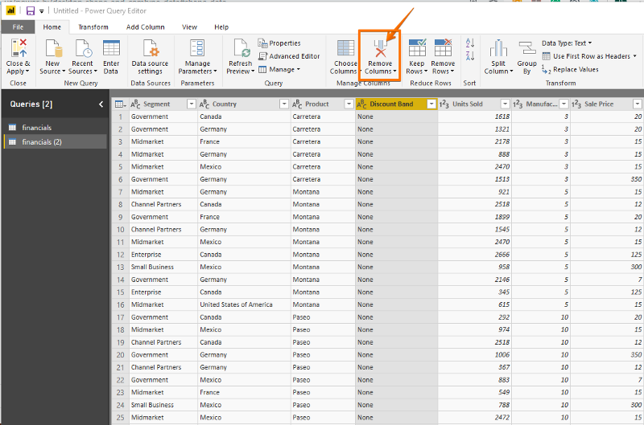

Similarly, there are other multitudes of functions that can be carried out like removing and adding rows, transpose, pivot and split which can be easily achieved through the query editor. Note that all the steps that you undertake to transform your data also appears in the Query Settings panel.

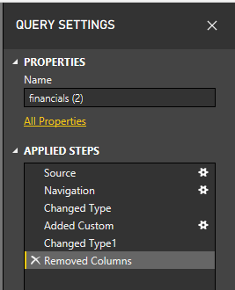

**6. Reports**

Reports are a collection of visualizations that can be created on one or more pages. These visualizations are usually related to one another.

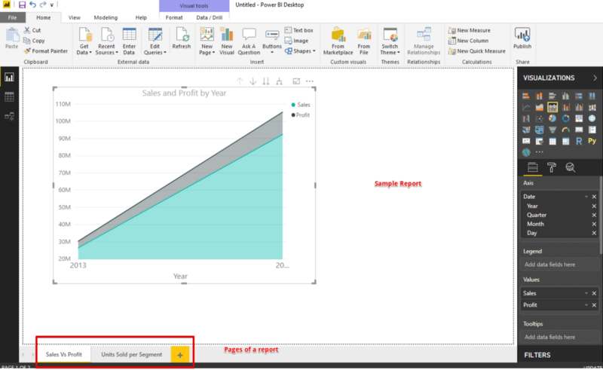

**7. Dashboard**

A dashboard is a collection of several views, enabling one to compare a variety of data simultaneously. Whereas the report can encompass various pages, a Dashboard is a single page interface.

**Creating a Dashboard**

Once we have the dataset ready with all the manipulations done, we can proceed for **the Dashboard** creation process. A Power BI dashboard, also known as canvas, consists of many visualizations on a single page which helps to tell a story. These visualizations called **tiles** are pinned to the dashboard from the reports.

Let’s now try to understand what insights we can get using superstore data set:-

* **Sales by Country**



* **Sales and Profit by Segment**



* **Sales & Profit by Month**



* **Sales by Product**



* **Profit by Discount Band**



The Dashboard created is interactive which means a change in one tile affects the other.



**In Lab Task**

Create the following data set from the dataset provided to you.

